(Approx. 1,011 words)

OAG Joins the Facebook Generation(s)! Part 2
By Mike Morris, Editor, Front Range PC Users Group, CO
www.frpcug.org
http://www.frpcug.org
twriterext (at) gmail.com

This article has been obtained from APCUG with the author’s permission for publication by APCUG member groups; all other uses require the permission of the author (see e-mail address above).

Hello again. This is the Old Analog Guy with Part 2 of my story about joining the Facebook generation.

I need to warn you that I am a novice at this social networking phenomenon—just in case it isn’t obvious.

In Part 1 I described the various privacy controls offered by Facebook. In this segment I want to (try and) describe (to the extent that I understand them) the two primary pages of a Facebook account:

- Home Page (also known as News Feed)
- Wall (also known as Profile)

Here is a view of my Home Page:

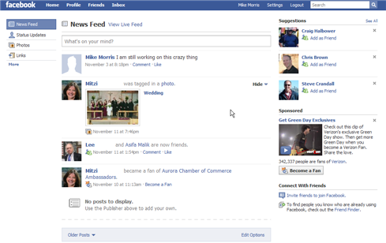

Here is a view of my Profile (Wall) page:

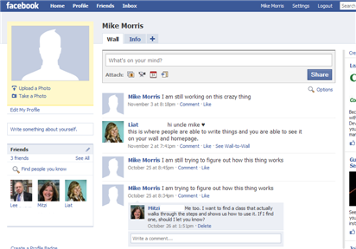

So . . . what is the difference?

Both have the “What’s on your mind?” field. Both have messages that I have posted and that “friends” have posted (although the list is not the same).

According to Wikipedia (http://en.wikipedia.org/wiki/Facebook): “A user’s Wall is visible to anyone who is able to see that user’s profile, depending on privacy settings.” The Wall can include both text and attachments. Well . . . OK, but that is an unsatisfactory explanation (to me) of the difference between the Home Page and the Wall.

One difference between the two pages is the list of “friends” on the left side of the Wall. If I click on a photo (or name) of a “friend” in that list, I am connected to that “friend’s” Wall (not to that “friend’s” Home Page). In fact, as best as I can determine, I can’t connect to a “friend’s” Home Page, only that “friend’s” Wall. So here is how I see the difference between these two pages (based on my testing, with results potentially different if privacy settings are different):

- My Home Page is a collection of messages posted by me and my “friends”. It is (apparently), only visible to me.
- My Wall displays messages posted by me (and, under certain conditions, my “friends”) and is visible to those I allow access. The Wall is also a link to other “friends.”
- If I post a message from my home page (News Feed), it will be displayed on both my home page and my Wall. It will not be displayed on “friends’” Walls. It will be displayed on “friends’” home pages (Live Feed but not News Feed).
- If I post a message from my Wall, it will be displayed on my Wall and on my Home page (both News Feed and Live Feed). It will not be displayed on “friends’” walls. It will be displayed on “friends’” home pages, but only on Live Feed, not News Feed.
- If I post a message to a “friend’s” Wall from my computer (I click on the “friend’s” name or photo that is displayed on my Wall), it will be displayed only on that “friend’s” Wall (not on any other “friend’s” Walls). It will not be displayed on that “friend’s” home page (either News Feed or Live Feed). It will not be displayed on any other “friend’s” home pages. It will not be displayed on my Wall or on my home page.
- If a “friend” posts a message to my Wall from that “friend’s” computer, it will be displayed on my Wall and my home page (both News Feed and Live Feed). It will be displayed on that “friend’s” home page (Live Feed but not News Feed). It will not show up on that “friend’s” Wall, nor will it show up on any other “friend’s” Walls or home pages.

Do you follow all that? I think I have the mechanics of using these two pages correct. However, as I said in my Facebook post, the logic of using two pages—especially the logic regarding what is displayed (or not displayed) on each page—still is not clear to me.

According to the Wikipedia article:

“One of the most popular applications on Facebook is the Photos application, where users can upload albums and photos. Facebook allows users to upload an unlimited number of photos, compared with other image hosting services such as Photobucket and Flickr, which apply limits to the number of photos that a user is allowed to upload. ... Another feature of the Photos applications is the ability to “tag”, or label users in a photo. For instance, if a photo contains a user’s friend, then the user can tag the friend in the photo. This sends a notification to the friend that they have been tagged, and provides them a link to see the photo.”

If you look at my Home Page, you will see that one of my “friends” “was tagged in a photo.” It wasn’t MY “friend” that did the “tagging.” It was a “friend” of MY “friend,” but I received notification, as did, presumably, all of MY “friend’s” “friends.” That message only appears on my Home Page, not on my Wall. Actually, I am not sure why it is displayed on any page of my Facebook account, since I have disabled everything in the “News Feed and Wall” privacy options and in the “Applications” (Photos is an “Application” which I have not installed) privacy options, and limited everything in the “Profile” privacy options to “Only Friends.” I suspect I don’t completely understand those privacy options.

I need to stop here. Just describing how this thing works starts short circuits in my brain—after all, I am an Old Analog Guy. I will try to describe, in Part 3, how you find “friends,” for those who need more friends, and for whom “old fashioned” telephone and email contacts are not sufficient.

I will end this story with references to some very interesting information on just how pervasive social networking has become—in all age groups of the population.

